Matlab Auditory Periphery (MAP) Model technical description

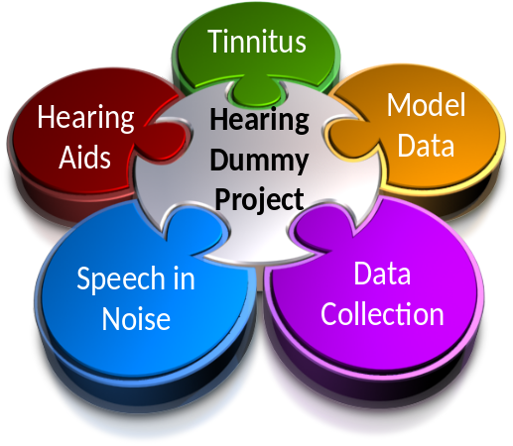

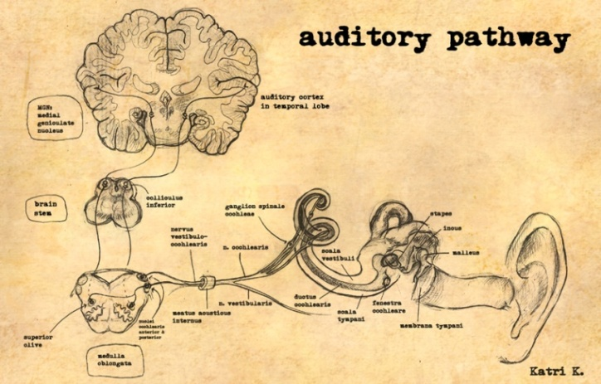 | Hearing Research Lab  University of Essex  2011  Volume 1, Issue 1

Contents
1. Introduction 4
1.1. The model structure 4
1.2. Recent changes 5
1.3. Parameters 5
1.4. Units 5
1.5. Evaluation programs 5
2. Input Stimulus 7
3. Outer and middle ear (OME) filtering 8
3.1. External ear 8
3.2. Stapes 8
3.3. Acoustic Reflex (AR) 9
3.4. OME evaluation 10
4. Outer and middle ear (OME) filtering 11
4.1. Nonlinear pathway 13
4.2. Linear pathway 14
4.3. BM summed output 15
4.4. Basilar Membrane: Evaluation 15
5. Inner hair cell (IHC) 19
5.1. Transduction at the stereocilia 19
5.2. Receptor Potential 21
5.3. Receptor Potential 22
6. IHC/ AN synapse 24
6.1. Calcium influx 25
6.2. Quantal and probabilistic models of vesicle release 27
6.3. Probability computations 28
6.4. Quantal computations 29
6.5. Synaptic vesicle release: Evaluation 30
7. Auditory Nerve response 31
7.1. Probability computations 31
7.2. Quantal computations 32
7.3. Auditory Nerve firing: Evaluation 33
Rate/ level: Evaluation 33
Phase-locking: Evaluation 34
8. Brainstem 35
8.1. Dendrites 36
8.2. Soma 37
8.3. Connectivity 38
8.4. Cochlear Nucleus units 40
8.5. Cochlear Nucleus units 41
8.6. Cochlear Nucleus: Evaluation 43
9. Efferent activity (AR and MOC) 45
9.1. Acoustic Reflex 45
9.2. MOC Reflex 47
9.3. AR and MOC: Evaluation 48
Attenuation of BM response 48
9.3.1. AR and MOC: Evaluation 49
9.4. AR and MOC using the probability model 50
10. Bibliography 51

Distribution
This software is freely shared on the understanding that the recipient accepts full responsibility for how it is used. The author makes no guarantees of any kind by sharing this software. If you know someone who wants a copy, please refer them to the author who will send them the latest bug-free version of the software. Otherwise, old versions circulate to the detriment of our reputation!
This is work in progress. Please send comments, criticisms and suggestions to the author rmeddis@essex.ac.uk

Errors, corrections and comments
Please contact the author if you spot any errors. This technical description will be frequently revised. Revisions will be identified by the issue number.
It will also be useful if you indicate any part of the text you found difficult to follow. Any suggestions you have can make the document more useful to other members of the auditory research community.

Introduction

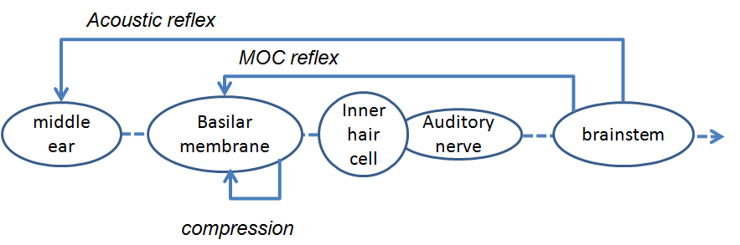

The computational model of the auditory periphery is evolving and improving. This account represents the model as it is currently used in our laboratory. This implementation of the MATLAB Auditory Periphery model is called MAP1_14. The computer code that realizes these equations and procedures can be found in the MatlabAuditoryPeriphery package. This can be downloaded from
http://dl.dropbox.com/u/13144068/MatlabAuditoryPeriphery.zip

The model structure
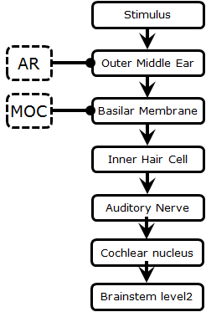
The model consists of a cascade of stages:
- Outer and middle ear (OME)
- Basilar membrane
- Inner hair cell
  - Stereocilia
  - Receptor potential
  - Synaptic calcium influx
- Auditory nerve/IHC synapse
- Refractory Effect
- Cochlear nucleus sustained chopper (CS) cells
- Brainstem level 2 neurons (can be MSO or IC cells)

Each stage is simulated by a set of computational formulae. These are described in sequence below.
Figure 1: Matlab Auditory Periphery (MAP) model structure

Recent changes
The most recent published account is Meddis (2006). However, the model has evolved considerably since then. The most notable additions concern the acoustic reflex and the medial olivo-cochlear effects. The use of feedback loops has required that the model be evaluated in short 10-ms segments. This is handled automatically by the MAP1_14 code.
Another important difference concerns the use of displacement measurements. The calculations in the original model were based on velocity, while the new model is based on displacement (see for example, Ruggero et al. 1986). The modeling advantage of a displacement formulation over velocity is that the model works well using the same value for many parameters at all locations along the basilar membrane (i.e. at different best frequencies, BFs). The earlier velocity formulation required different values for each location. This results in a considerable simplification of the system of parameters.

Parameters
The recommended parameters for normal hearing can be found in the in the MAPparamsNormal file in the MatlabAuditoryPeriphery\MAPparameters folder. All parameters are stored in a single file but parameters are stored in separate structures for each stage of the model. For example, outer middle ear parameters are stored in the structure OMEparams. Parameters from the MAPparamsNormal file are shown in this style throughout this document
OMEParams.stapesScalar= 45e-9;

The values in the MAPparamsNormal file should be taken as superseding any values given below which are shown for illustrative purposes only. This document is not automatically updated when the parameters are changed.

Units
All parameter and measurement units are international units (meters, seconds, volts, etc.).

Evaluation programs
The MAP model is a cascade of sub-models. A problem with any one stage will propagate to all subsequent stages. It is important therefore to check that each individual stage is functioning satisfactorily.
The MatlabAuditoryPeriphery package contains a number of programs to allow the code at each stage to be evaluated individually. These are located in the testPrograms folder of the software package. These will be illustrated in a separate ‘evaluation’ section at the end of the description of each stage.
These programs are designed to give a useful output when run with no arguments. For example, ‘run testBM’ typed in the command window will give an evaluation of the basilar membrane simulation of the model at a single location with best frequency=1-kHz probed with a 1-kHz pure tone at a range of levels. However, most of these programs allow optional arguments that offer flexibility in terms of the details of the test. Typing ‘help testBM’ will give further details (if testPrograms is your current folder). Alternatively, open the program and explore the code, adapting it where required.
The Evaluation sections are continually being expanded. It will not be possible to explain all of the evaluations thoroughly in this document; some would require a short paper in themselves. If any are of particular interest but are unclear, please write to the author (rmeddis@essex.ac.uk) for more details.

Input Stimulus
The input to the model is a single-channel (mono) acoustic pressure waveform expressed in Pascals (NB not microPscals).
Repeat: the waveform is expressed in Pascals (and not microPascals or arbitrary units). The units are important because the model is nonlinear and level dependent.
The signal is represented as a single-row horizontal (mono) vector. MAP cannot handle two-channel (stereo) signals at present.
The sample rate is supplied as a model parameter:
inputStimulusParams.sampleRate= 44100;

The pressure wave is sampled at intervals of dt, where dt=1/inputStimulus.sampleRate.

Outer and middle ear (OME) filtering

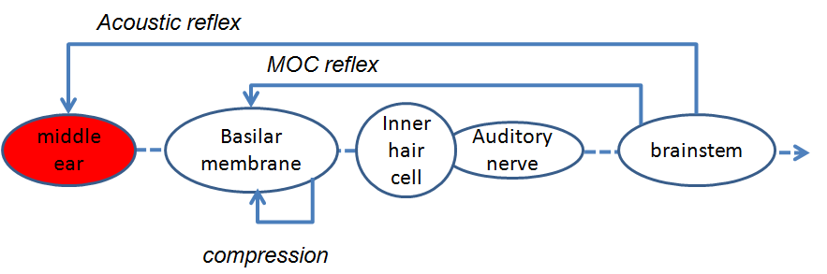

External ear
The input to the external ear is a sound pressure wave (Pa).
The output from the external ear is the original sound pressure wave plus a resonance.
The resonance is modelled as two parallel bandpass filters representing the ear canal resonance and the concha resonance repectrively. The two resonances are represented in the MAPparamsNormal parameter file as
OMEParams.externalResonanceFilters= [ 10 1 1000 4000;
25 1 2500 7000];
where the resonances are described by vectors [gain, order, low- and high-cutoff frequencies].
The output from these resonances are summed with each other and with the original pressure wave.
This stage has not yet received the attention it deserves and these parameters may change in later versions.
The output from this stage and the input to the next is sound pressure (Pa) at the tympanic membrane (TM).

Stapes
The method for simulating the stapes response is a departure from our earlier published methods which used a band pass filter to simulate cadaver measurements. The current version simulates stapes measurements made in live-human patients, Huber (2001). Cadaver and in vivo measurements do not agree (Ruggero and Temchin, 2002) and we have adapted the model to simulate the live human data.
When matching the model data to the data of Huber et al., we take account of the fact that they placed the loudspeaker inside the ear canal and, therefore, the concha filter does not apply and is switched off for the purpose of the comparison. The concha filter is enabled in the standard human model.
A second departure from earlier versions of MAP is the use of displacement measurements rather than velocity. This change is more important than it may seem at first sight. Sound pressure, p, equates with velocity, v, irrespective of frequency after application of a constant, k, such that
p= kv

However, when velocity is converted to displacement, frequency matters. For frequency, f, the corresponding displacement, d, is calculated as,
d= v/ (2 π f), d = k p / (2 π f)

In other words, a doubling of frequency results in a halving of displacement. In practice this conversion is computed by applying a 1st-order Butterworth low pass filter with a low cut off frequency (50 Hz). This produces a 3-dB roll off in displacement with frequency; a result that agrees with the human stapes measurements above 2 kHz.
A scalar (45e-9) is also applied in the conversion from velocity (m/s) to displacement (m)
OMEParams.stapesScalar= 45e-9;

While the conversion to displacement (in meters) gives a good fit to the human stapes data at high frequencies (>2 kHz), it is necessary to add a high-pass filter to limit displacements at very low frequencies(presumably reflecting the stiffness of the system. This is done by applying a 1st- order, high pass Butterworth filter to the TM displacement. The cut-off frequency of this filter is 1000 Hz
OMEParams.OMEstapesHPcutoff= 1000;

The output of this stage is stapes displacement, d_{t} (in meters).

Acoustic Reflex (AR)
The acoustic reflex (AR) attenuates stapes displacement in response to loud sounds. This is modelled as a negative feedback loop using a variable attenuation scalar, AR_{t} .
d_{t} = AR_{t} d_{t}

The computation of AR_{t} is described below in the Acoustic Reflex section below.

OME evaluation
The resulting stapes displacement as a function of frequency can be observed using the testOME program in the testPrograms folder. This charts the model external ear filter response as a function of frequency. It also charts the stapes displacement as a function of stimulus frequency and compares it with intra-operative live-human data of Huber et al. (2001).
The upper panels in the Fig 2 compare measurements with the model response. The model external ear resonance figure shows the external ear resonance (lower line) and the combined response (with the concha resonance) in the upper line. Fig. 3 compares the model stapes response with the Huber data. The lower line gives the response with the concha resonance removed (to simulate Huber’s experimental conditions) and the upper line gives the full model response.
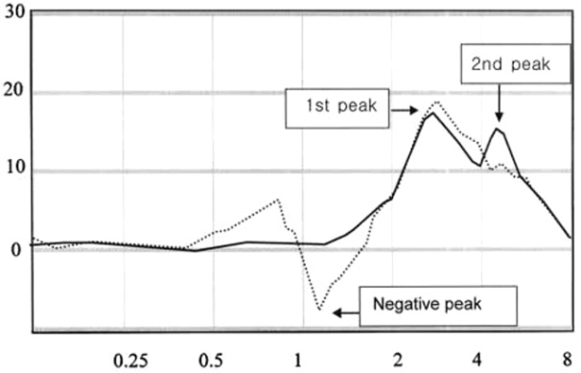 | 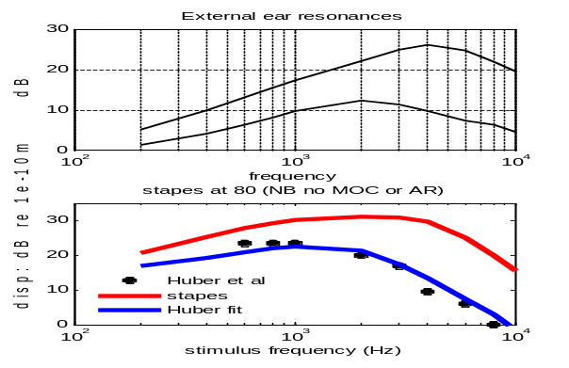
Figure 2: External ear resonances in human ear (left, Cho et al (2001)) and model (right).
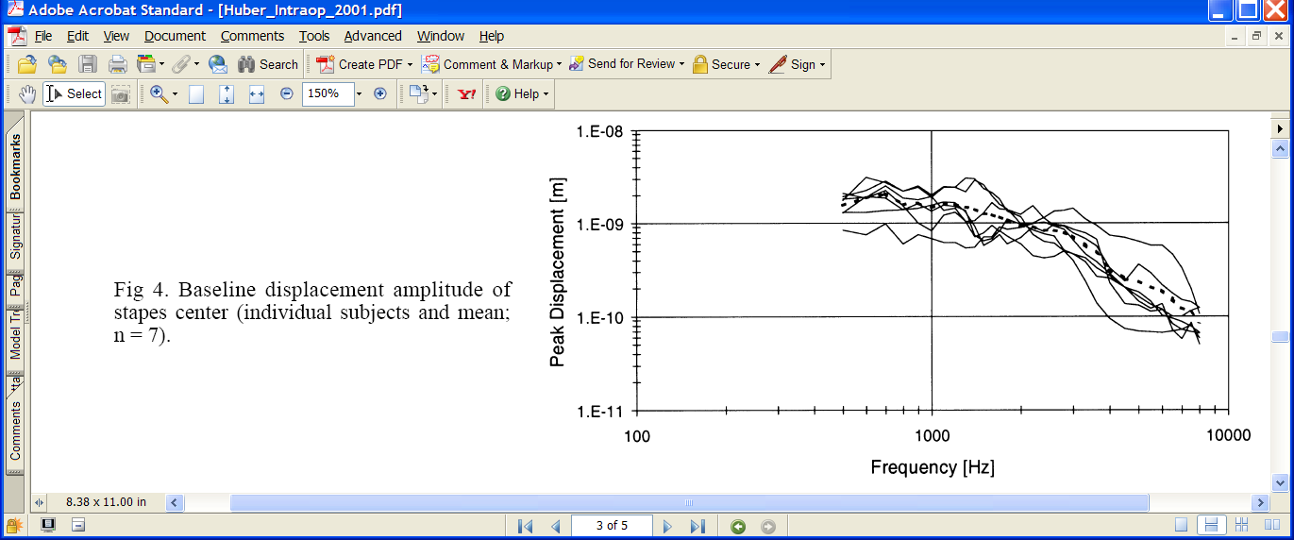
Figure 3: Left: Peak stapes displacement measurements using live human patients from Huber et al. (2001). Right: comparison of model (red line) with mean Huber data (black dots). 80-dB SPL pure tones are used both for the patient observations and the model simulation. The simulation does not include any acoustic reflex because the patients in this study were deaf. Also the (lower) blue line does not include the concha component of the external ear filter because the loudspeakers were inserted into the external auditory canal.

Outer and middle ear (OME) filtering
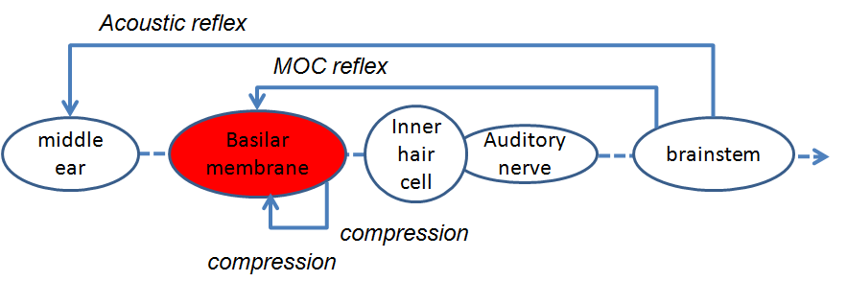
The filtering of the BM is modelled with a ‘Dual-Resonance-Non-Linear’ (DRNL) filter architecture that has been described and evaluated more fully elsewhere (Meddis et. al., 2001; Lopez-Poveda and Meddis, 2001; Sumner et al., 2003b).
The input to this stage is stapes displacement.
The challenge is to simulate physiological measurements of BM displacement. The input/output function is often described as having three components:
- Linear response at low signal levels
- Compressed response at intermediate levels
- Almost linear response at high signal levels

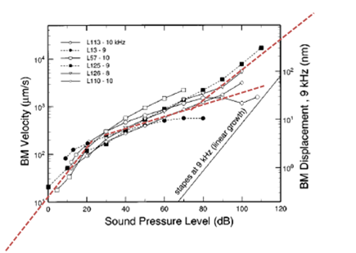
Figure 4: BM I/O functions. BM velocity/displacement measurements made by Ruggero et al. (1997) in the chinchilla. All I/O functions are measured in the base of the BM with BFs in the region 9-10 kHz. (Displacement is the y-axis on the right.)
The BM is modelled at a number of discrete locations along its length, each identified by its best frequency (BF). The BFs of these locations must be supplied as a list, BFlist, by the user but, by default, are equally spaced on a log scale between two values. For example,
lowestBF=250; highestBF= 8000; numChannels=21;
BFlist=round(logspace(log10(lowestBF),log10(highestBF),numChannels));

The BF of a location is used loosely here as ‘the frequency generating the greatest BM response near hearing threshold’. The wording of this definition is important because ‘the most responsive frequency’ changes with the level of the test stimulus. The BF is an ‘emergent property’ of the model rather than a parameter. It shifts as a function of level. It is the center frequencies (CFs) of the component filters of the DRNL that are parameters of the model.
The DRNL filter consists of two parallel pathways, one linear and the other non-linear. Their outputs are summed to produce an output representing the displacement of the cochlear partition at a particular location. We shall consider each pathway in turn.
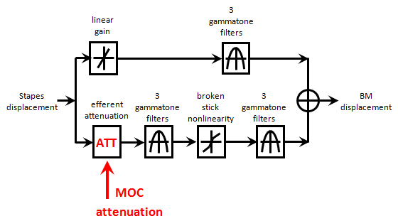

Figure 5: Schematic of the DRNL simulation of BM displacement at a single location. The upper path is the ‘linear pathway’. The lower path is the ‘nonlinear pathway’.

Nonlinear pathway
The nonlinear pathway consists of the following cascaded sequence:
- An efferent attenuation represented by a variable scalar (explained in the section on the efferent system below, MOC)
- 3 identical first-order gammatone filters (DRNLParams.nonlinOrder= 3;)
- A broken-stick compression function
- 3 identical first-order gammatone filters

Centre frequencies. All filters in the nonlinear pathway at a given location have identical center frequencies, nonlinCF , equal to the BF near threshold of the location.
DRNLParams.nonlinCFs=BFlist;

Bandwidths. All gammatone filters in the nonlinear pathway at a specific location have the same bandwidth, nonlinBW. However, bandwidths increase with BF. They are computed using the empirical equation
nonlinBW(BF)= p * BF+ q
DRNLParams.p=0.14;
DRNLParams.q=180;
N.B. these bandwidths are merely component bandwidths and not the same as the bandwidth of the whole system.

Compression. The input/ output (I/O) function of the BM peak displacement is linear (1 dB/dB) up to some displacement threshold. Above this displacement, the function has a reduced slope (say, 0.2 dB/dB). This is simulated by a ‘broken-stick’ compression function, which is linear below a compression threshold, ctBM
for |x_{t}| <= ctBM h_{t}=a x_{t}
where x_{t} is the input after MOC attenuation, a is a scalar and ctBM is a scalar displacement (m) value.
DRNLParams.a=5e3;

For convenience, the compression threshold is specified as dB above a reference value of 1e-9 m. 1 micrometer is a value that is close to threshold for normal hearing.
DRNLParams.CtBMdB = 25; and CtBM=1e-9* 10^(CtBMdB/20);

When the displacement is greater than ctBM, a formula is used to generate an input/output function on a dB/ dB scale with a slope of c starting at the point of intersection with the linear function described immediately above. Note that the formula is applied to the modulus and then the sign is restored later.
for |x_{t}| > ctBM h_{t}= sign(x_{t}) ctBM exp(c log(a| x_{t}|) / ctBM))
DRNLParams.c=0.2;

The parameters a, CtBM and c have the same value at all locations along the BM. This is a major change from previous published versions of the model; it is a consequence of using displacement rather than velocity.
The compression formula differs from an earlier published formula that simply raised x_{t} to a power (in this case, 0.2). It provides a more sensible fit at the point of intersection but is somewhat cumbersome and lacks transparency.

Linear pathway
The linear pathway consists of the following cascaded sequence:
- A scalar, g, representing gain or attenuation
- A cascade of 3 identical gammatone filters

DRNLParams.g=50;
DRNLParams.linOrder=3;

These values are true for all BFs.
The CF (linCF) of the gammatone filters in the linear pathway is not the same as the nonlinCF in the corresponding nonlinear pathway. The difference in CFs of the two pathways is important and accounts for observed shifts of the BF of the filter at higher stimulus levels. linCF is computed using the following empirical equation
linCFp=266; linCFq=0.621;
DRNLParams.linCFs= linCFp + linCFq *BFlist;

The bandwidth is specific to the location along the cochlear partition of the linear filters are computed using the empirical formula
linBWp=0.1; linBWq=235;
DRNLParams.linBWs= linBWq + linBWp=0.1;*BFlist;

BM summed output
The outputs of the two pathways are summed to give the BM displacement of the individual locations.
The phase characteristics of the two pathways are different and this summation may give rise to phase cancellation for pure tone stimulation. This is sometimes observed in physiological recordings and is known as ‘Nelson’s notch’ (Kiang and Moxon, 1972).

Basilar Membrane: Evaluation
The resulting BM displacement as a function of level can be evaluated using the testBM program in the testPrograms folder.

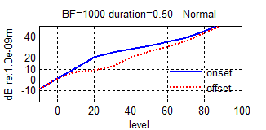
Figure 6: Blue continuous line (upper): Basilar membrane input/output function at 1 kHz. Output is peak displacement in dB re 1e-9m at signal onset. Lower dotted red line: same as blue line but measured after 0.5 sec. The difference between the two lines originates with the slowly activating efferent attenuation. This result is generated using testBM function without any arguments. Input level is dB SPL.

The testBM program can be used to evaluate I/O functions at a range of BFs and stimulating frequencies an can be used to generate iso/displacement tuning curves. The middle row shows the amount of efferent MOC attenuation as a function of level and stimulating frequency.
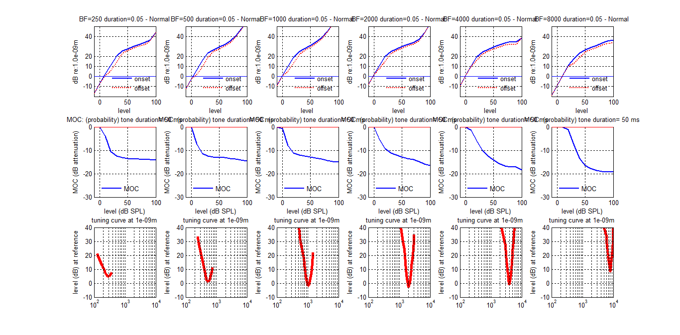
Figure 7: Basilar membrane evaluation at 6 BFs (250, 500, 1000, 2000, 4000 and 8000 Hz) for a 50-ms tone
Top row: peak displacement for BF-tones presented at a range of levels between -10 and 90 dB SPL.
Middle row: MOC attenuation (dB). This is the attenuation that is applied to the nonlinear path rather than the resulting attenuation at the output of the DRNL. Note that the response is nonlinear and the output attenuation can be much smaller than the MOC applied attenuation. The MOC has efferent effect build up slowly over time and the results can vary with the duration of the testing signal.
Bottom row: iso-response tuning curves at each BF tested at the relative frequencies used in the top row. An iso-response curve is a plot of levels required to generate a fixed (here 1e-9m) displacement of the BM.
To generate this figure use:
testBM ([250 500 1000 2000 4000 8000], 'Normal', [.5 .75 .9 1 1.1 1.25 1.5], 'probability', {}, 0, .05);
(and be prepared to wait!)

The I/O function can be compared with Ruggero et al’s data. The computed levels are slightly higher than the original but the overall shape is correct.
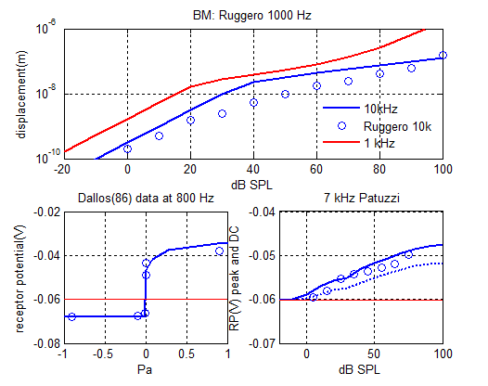
Figure 8: Comparison of model output with Rugerro (1997) data (unfilled circles). The lower continuous blue line is the model response at 10 kHz. The upper red continuous line is the model response at 1 kHz. These data were generated using:
testRP2('Normal');

The best frequency shift at higher signal intensity can be observed using test_DRNL_Ruggero97a (no arguments) in the testPrograms folder

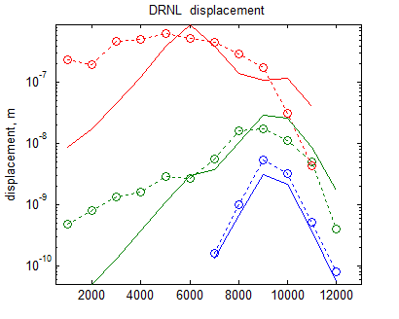
Figure 9: Iso-intensity curves comparing DRNL with chinchilla data and showing how the filter function broadens and the CF shifts with probe level. These data were generated by running test_DRNL_Ruggero97. The chinchilla data (open circles, dotted lines) are from Ruggero (1992). Model data (continuous lines) were generated using the parameters in the MAPparamsNormal file.

Inner hair cell (IHC)

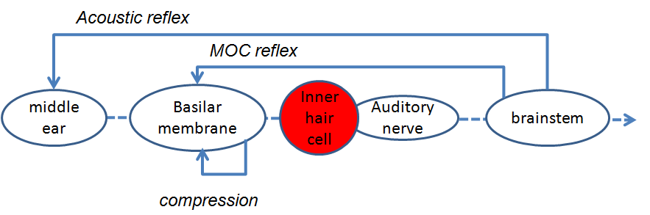

The IHC stage is divided into a cascade of two stages
- Conductance changes in the stereocilia
- Receptor potential changes in the body of the cell

This model of IHC transduction derives originally from Shamma (1986).

Transduction at the stereocilia
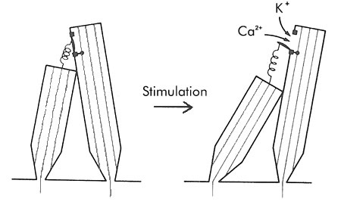
Figure 10: Displacement of the BM causes displacement of the IHC stereocilia which modifies the conductivity of the local ion channels. The coupling is not direct but indirect through the fluid (i.e. ‘viscous coupling’) between the BM and the tectorial membrane. Viscous coupling favours high frequencies at the expense of low frequencies.

The BM displacement, disp_{t}, is viscously coupled to the inner hair cell stereocilia displacement, u(t)
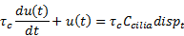
where C_{cilia} is a scalar converting BM displacement to cilia displacement and τ_{c} is a time constant
IHC_cilia_RPParams.C= 0.5;
IHC_cilia_RPParams.tc= 0.00012;

This equation represents a high-pass filter and can be evaluated using the MATLAB filter function, filter (b, a, disp_{t}), where
b= [1 dt/τ_{c}-1]; a= dt/τ_{c}-1

The cilia displacement, u(t), determines the apical conductance G(u). The total apical conductance is given by
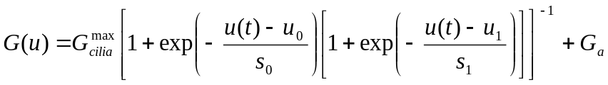
where G_{cilia}^{max} is conductance (in Siemens) when all transduction channels are open and G_{a} is a passive conductance in the apical membrane. s₀, u₀, s₁ and u₁ are constants determining the exact shape of the relationship.
IHC_cilia_RPParams.Gmax= 6e-9;
IHC_cilia_RPParams.Ga= 0.8e-9;
IHC_cilia_RPParams.u0= 0.3e-9;
IHC_cilia_RPParams.s0= 45e-9;
IHC_cilia_RPParams.u1= 1e-9;
IHC_cilia_RPParams.s1= 1e-9;

Receptor Potential
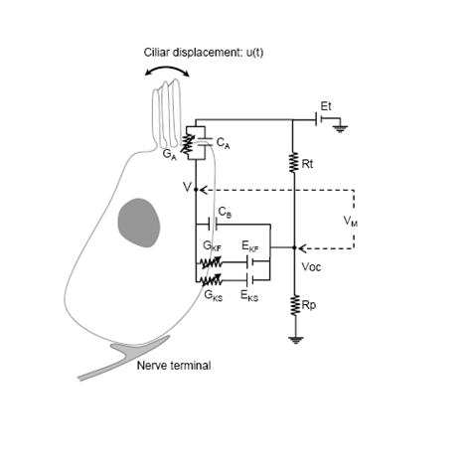
Figure 11: Receptor potential circuitry.

The membrane potential, V(t), of the cell body is modelled with a passive electrical circuit analog:
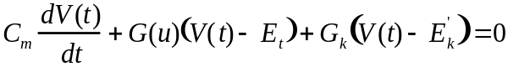
where C_{m} is the cell capacitance
G_{k} is a fixed (voltage-invariant) membrane conductance
E_{t} is the endocochlear potential
E_{k}’=E_{k} + E_{t}R_{pc}is the reversal potential of the basal current E_{k} corrected for the resistance, R_{pc}, of the supporting cells.
IHC_cilia_RPParams.Cab= 5e-012;
IHC_cilia_RPParams.Et= 0.100;
IHC_cilia_RPParams.Gk= 2.1e-008;
IHC_cilia_RPParams.Ek= -0.08;
IHC_cilia_RPParams.Rpc= 0.04;

Receptor Potential
The IHC response as a function of level can be evaluated using the testRP program in the testPrograms folder.
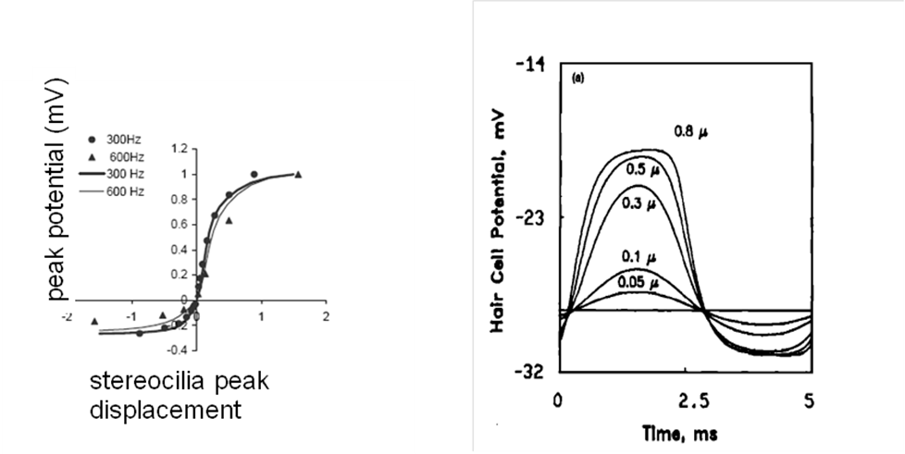
Figure 12: The conduction changes are asymmetric with respect to cilia displacement direction. This produces larger receptor potentials in the positive half of the cycle at all but the lowest stimulus levels. This asymmetry gives rise to a DC potential (taken from Shamma, 1986). The data in the left panel are from Dallos (1986).

The important characteristic of the transfer function is that it is asymmetric about zero at high displacements. Negative stereocilia displacements produce only small negative shifts in the receptor potential compared to positive displacements. This gives rise to a DC potential for many sound signals. While this is characterised often as ‘half-wave rectification’, it should be noted that the function is symmetric at low levels of displacement where no rectification is present.
The other characteristic is that the function saturates at high displacements producing a flat-topped appearance in representations of a single cycle.

Receptor potential: Evaluation
In the next figure, the model can be compared with Dallos (1986) data (shown above) at 800 Hz and input/output functions measured by Patuzzi and Sellick (1983) at 7 kHz.

Figure 13: Receptor potential model evaluation at two signal frequencies A:800 Hz and B:7000 Hz.
Bottom left: peak and trough receptor potential at different signal levels compared with equivalent 800-Hz data from Dallos (1986, open circles).
Bottom right: peak receptor potential input/ output function compared with 7000-Hz data (open circles) from Patuzzi and Sellick (1983). The continuous line is the AC potential (peak to peak) and the dotted line shows the DC potential (mean potential).

To produce these figures use
testRP2('Normal');

IHC/ AN synapse

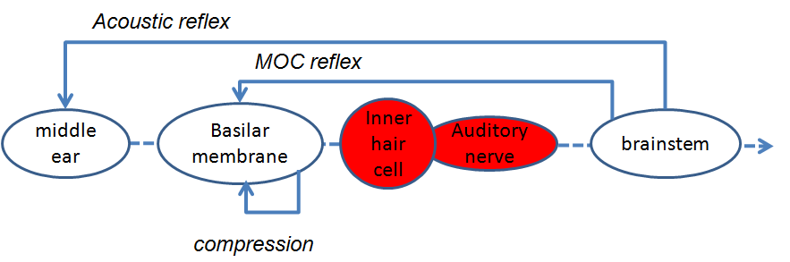

The IHC receptor potential influences the rate of firing of the auditory nerve at the synapse through the controlled release of transmitter vesicles. This control is managed by calcium concentration in the synaptic region. When the receptor potential rises, calcium flows into the cell and causes the vesicles present at the synapse to have an increased probability of release into the synaptic cleft where a single vesicle is assumed to be sufficient to generate an action potential. The action of the calcium is short-lived because it is rapidly removed from the synaptic site through dissipation or active chemical buffering.
It is convenient to treat this process as the cascade of two stages
- The influx of calcium
- The release of transmitter regulated by the amount of calcium present at the synapse

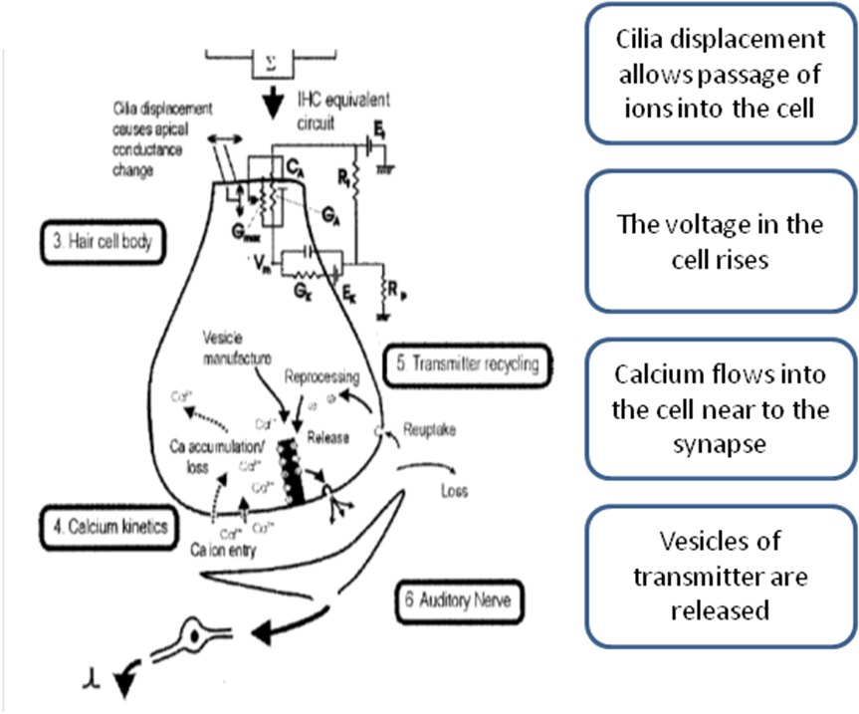
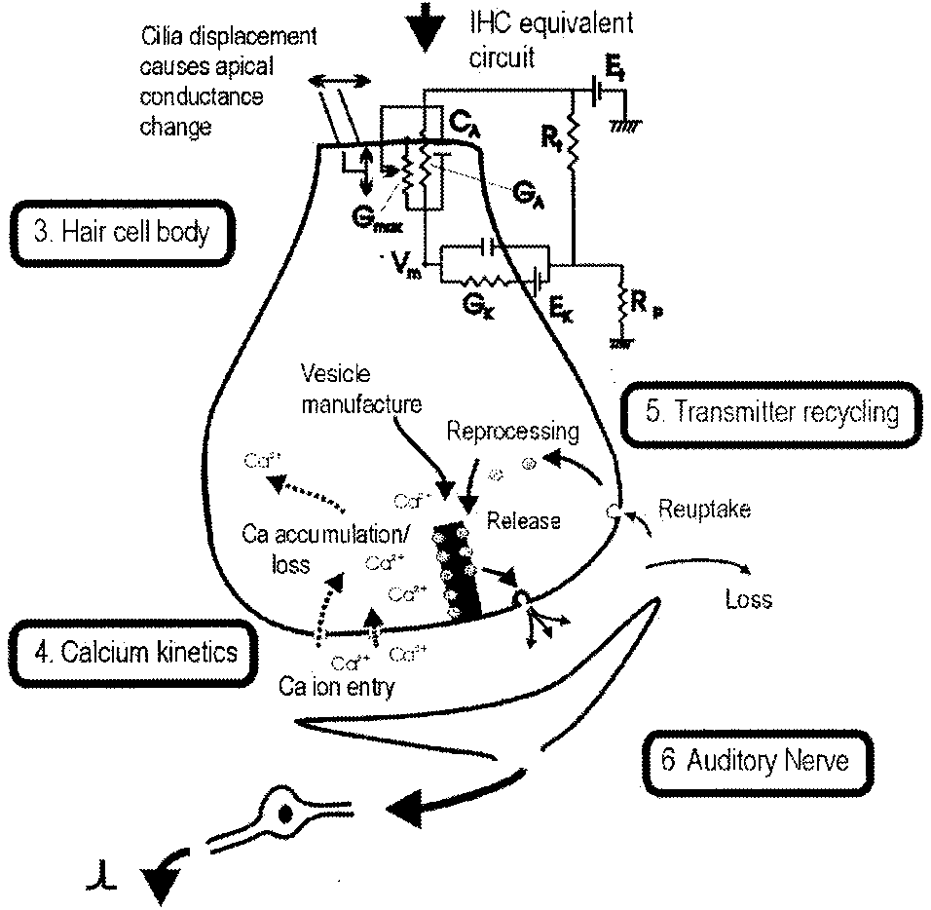
Figure 14: Voltage changes inside the IHC cause an influx of calcium ions into the cell which trigger transmitter release into the synaptic cleft.

Calcium influx
The Calcium current, Ica, is determined by the membrane potential
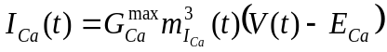

where E_{Ca} is the reversal potential for calcium and G_{Ca}^{max} is the calcium conductance in the vicinity of the synapse with all channels open
IHCpreSynapseParams.GmaxCa= 14e-9;
IHCpreSynapseParams.ECa= 0.066;

m_{Ica}(t) is the fraction of calcium channels that are open. Its steady state value, m_{Ica,∞}, is modelled by a Boltzmann function,
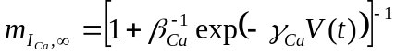
where γ_{Ca} and β_{Ca} are constants chosen to reflect published observations of calcium currents
IHCpreSynapseParams.beta= 400;
IHCpreSynapseParams.gamma= 100;

m_{Ica}(t) is a low pass filtered function of m_{Ica,∞}
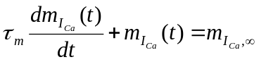
where τ_{m} is a calcium current time constant.
IHCpreSynapseParams.tauM= 0.00005;
Pre-synaptic calcium concentration [Ca²⁺](t) is modelled as a 1st order low-pass filtered function of calcium current, I_{Ca}(t)
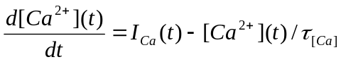
where τ_{Ca} is a time constant reflecting the dwell time of pre-synaptic calcium in the vicinity of the synapse.
The value of τ_{Ca} varies according to the desired spontaneous rate of vesicle release. τ_{Ca} controls the rate at which calcium is cleared from the region adjacent to the synapse. As a consequence it determines the release characteristics of the synapse. Low values for τ_{Ca} result in low spontaneous rate (LSR) synapses. High spontaneous rate (HSR) synapses can be modelled using higher values for τ_{Ca}. The software allows for HSR, MSR and LSR synapses to operate in parallel.
LSRtauCa=25e-6; MSRtauCa=45e-6; HSRtauCa=55e-6;
IHCpreSynapseParams.tauCa= [LSRtauCa MSRtauCa HSRtauCa];
The probability of the release of a single transmitter vesicle is proportional to the cube of [Ca²⁺] concentration:
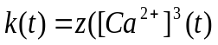)
where z is a scalar for converting calcium levels into release rate
IHCpreSynapseParams.z= 2e42;

Quantal and probabilistic models of vesicle release

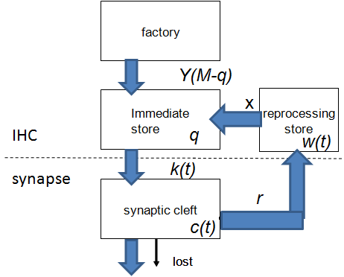
Figure 15: Flow diagram for transmitter vesicle release and recovery.

Individual vesicles of neurotransmitter (glutamate), are released from an immediate pre-synaptic store containing q(t) vesicles into the cleft at a rate, k(t), computed in the previous section. c(t) is the number of vesicles in the cleft at time t.
In the cleft, the transmitter disperses and some is lost from the system at a rate l. The remaining transmitter in the cleft is taken back into the cell into a reprocessing store (w) at a rate r. Here it is repackaged into vesicles that are returned to the immediate store at a rate x.
AN_IHCsynapseParams.l= 40;
AN_IHCsynapseParams.r= 50;
AN_IHCsynapseParams.x= 40;

The immediate store is replenished with new transmitter vesicles at a rate, y[M-q(t)] where M represents the maximum number of transmitter quanta that can be held in the immediate store.
AN_IHCsynapseParams.y= 10;
AN_IHCsynapseParams.M= 20;

In the real world, transmitter is released in small packets known as vesicles. In the model we can either track the movement of individual vesicles (quantised version) or can approximate their movement using a probabilistic account (probability version). Detailed accounts of transmitter release in a probabilistic form can be found in Meddis (1986, 1988) and Hewitt and Meddis (1991) and Sumner (2003a and 2003b). A description of the quantized version is given in Sumner (2002).
The probability version is easier to follow and quicker to compute. The quantised version is slower to compute and a little trickier to follow conceptually but it introduces the important property of stochasticity into the model of the AN response. The stochastic nature of AN firing patterns is an important feature of auditory processing. The stochastic model is essential if brainstem modelling is to be attempted because the neuronal models require input in the form of stochastic spike trains.

Probability computations
For the probability model we ignore the complications associated with quantised release so that the transmitter can be treated as a continuous substance and the quantities tracked as follows

(change in q = reprocessed +manufactured – released)
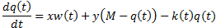

(change in c = released - lost – recovered)
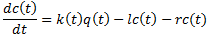

(change in w = recovered - reprocessed)
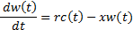

Quantal computations
A more realistic model treats transmitter substance as a small integer value representing the number of vesicles. When a vesicle is released into the cleft its packet nature is briefly lost and the transmitter is dispersed as a substance. It is then partly from the system and partly taken back up into the cell. After re-uptake, it is repackaged once again into vesicles and transported back into the immediate store ready for release again.
The neurotransmitter in the immediate store consists of q(t) individual vesicles. Each vesicle enters and leaves the immediate store stochastically. The number of vesicles released in a single epoch of time is described by the function N(q(t),ρ) where ρ is the rate of release. Each of the q quanta has an equal instantaneous probability of release, ρ.dt. The function N computes t the number of vesicles released in a single epoch. In simulation terms, each vesicle gets a single roll of the dice at each epoch and may or may not be released. The function N can be estimated using the following equation taken from probability theory
N(q_{t}, q_{t}k_{t})= 1 – (1 – K_{t} dt) ^{q(t)}

Transfers into and out of the immediate store are in vesicular form and use this equation. However, in the cleft and reprocessing stores, transmitter is a continuous quantity (because the molecules are released from the vesicular bag) and can be estimated as rates applied to continuous quantities.

The following simultaneous equations represent the flow of transmitter through the system.
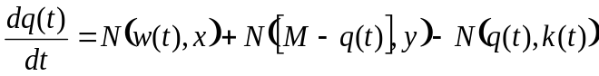
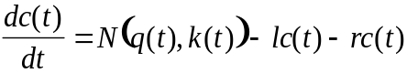
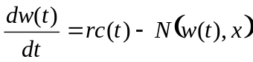

Initial (boundary) values for the variable quantities are found as follows (Meddis, Hewitt and Shackleton, 1990):
c₀= k₀ y m / (y (l + r) + k₀ l) , q₀= c₀ (l + r) / k₀ , w₀= c₀ r / x
where k₀ is the resting value of k(t) found by evaluating k(t) for u(t)=0 in the previous section.

The evaluation of the movement of transmitter substance is computationally intensive. To ease this burden, the evaluation is normally carried out at a lower sample rate (around 10 kHz) by down-sampling k(t) by a speed-up factor. For a signal sample rate of 50 kHz, an appropriate speedUpFactor would be 5. A strict sampling rate cannot be specified arbitrarily because the final value must be a factor of the original sample rate. The program will find the most appropriate value in the region of the target rate.
AN_IHCsynapseParams.spikesTargetSampleRate=10000;

If more than one type of synapse (e.g. HSR, LSR) is modelled (by employing more than one value for τ_{Ca}), independent parallel streams of AN fibers are computed.

Synaptic vesicle release: Evaluation
The resulting available transmitter as a function of level can be evaluated using the testsynapse program in the testPrograms folder.
During acoustic stimulation, the amount of available transmitter declines but then recovers afterwards. testSynapse tracks these changes at different signal levels.

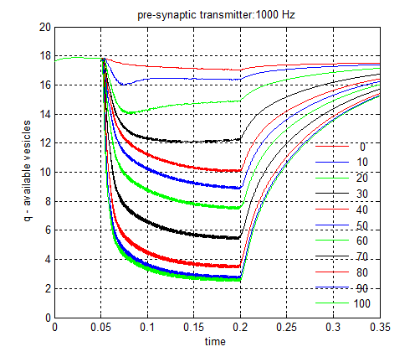 | 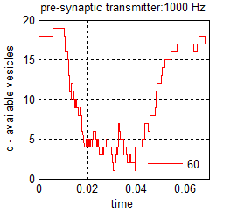
Figure 16: Plot of the quantity of transmitter available for release, q, during and after stimulation by a 1000-Hz, 150-ms pure tone. The maximum quantity allowed in the available store is 12 vesicles. Note that vesicles are continuously being released even in quiet and this explains why the average value of q never exceeds 18. Left panel: probability model tested at 6 different tone levels. Right panel: quantised (stochastic) model tested at a single level (60 dB SPL). For the purpose of these demonstrations, the acoustic reflex is inactivated.

Auditory Nerve response

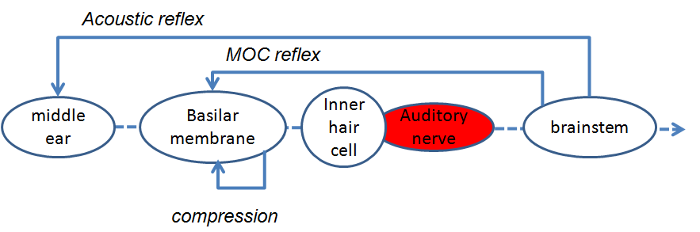

The response of the auditory nerve (AN) is relatively straightforward because the model assumes that the release of a single vesicle of transmitter into the cleft is sufficient to trigger an action potential in the auditory nerve. This is a working assumption and subject to experimental verification. The only complication is the presence of an absolute and a relative refractory period following an action potential.

The model simulates the response of ensembles of large numbers of AN fibers either literally or as a probability that represents the average of the ensemble. It segregates LSR and HSR fibers into different groups or streams.

Probability computations
If the model is computed in probability mode, the firing rate is based on the quantity c(t), the amount of transmitter in the cleft
ANrate= c(t) / dt

A refractory effect is now simulated on the basis of the following principles. A 0.75 ms absolute refractory period is assumed
AN_IHCsynapseParams.refractory_period= 0.00075;

The probability of a spike’s having occurred in this period can be estimated as
P_{fired}= 1 – II (1-p_{t-1})
where II (1-p_{t}) indicates the product of all probabilities of not firing in the immediate past, i.e. during the refractory period between (t-refractory period) and t-1. The reduction in the probability of firing in the current epoch, t, is proportionatal to the likelihood that a spike did occur in that period.
P’_{t} = P_{t} P_{fired}

In probability mode, no adjustment is currently made for the relative refractory period.

Quantal computations
An action potential can be generated in an auditory nerve whenever at least one vesicle is released into the synaptic cleft unless the fiber is refractory.
An absolute refractory period lasting 0.75 ms is applied; if one spike follows another within this period, the second one is deleted from the record
AN_IHCsynapseParams.refractory_period= 0.00075;

At the end of this period, a relative refractory period is enforced. During this period a release event is converted into a spike on a probabilistic basis as a function of time, t, since the last spike
P_{conversion}= 1- exp(t / 0.0006)

The spike patterns of a large number of AN fibers (>50) are computed within each channel.
AN_IHCsynapseParams.numFibers= 100;

Auditory Nerve firing: Evaluation

Rate/ level: Evaluation
Estimates of spike rates can be obtained using either of two test programs; testANprob and testAN located in the testPrograms directory. Two types of spike rate are computed; 1) the onset rate, based on the number of spikes in the post-stimulus period histogram (PSTH) bin with the most spikes near the onset of the stimulating tone (essentially, the height of the peak of the PSTH). Spike rates are also computed for two types of fiber (HSR and LSR). HSR are the upper series in black and LSR is the lower series in red. These are modelled using two different calcium time constants, τ_{Ca}
LSRtauCa=30e-6; HSRtauCa=80e-6;

The figure compares the probabilistic version with the stochastic spike-generation version. In this example, the probability estimates are not the same as the stochastic outcome because the latter is subject to random fluctuations between trials. This is particularly evident for the onset rates which are narrowly based on a 1 ms interval.

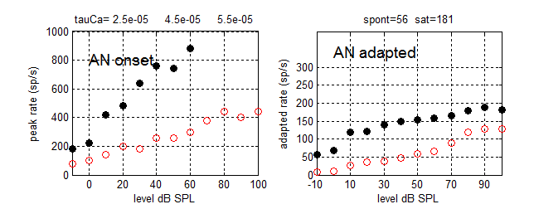
Figure 17: AN response (spiking rate) for HSR (black circles) and LSR (red circles) fibers in response to 200 ms tones at BF. Within each panel the left chart shows onset rates and the right chart shows adapted rates.
Results were generated using
testAN(1000,1000, 10:10:80,'Normal',{}, 0);.

Phase-locking: Evaluation
Johnson (1980) measured the vector strength of AN single-fiber spike activity with respect to the frequency and level of the stimulating tone. A model can be evaluated in this respect using the testPhaseLocking program.

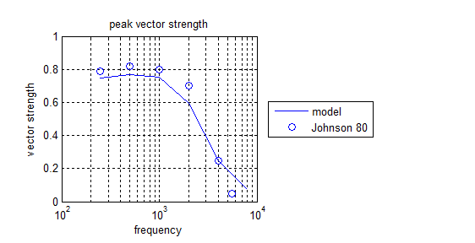
Figure 18: Upper panel: maximum synchronization indices (across all tested levels) as a function of frequency. Open circles are based on Johnson’s (1980) data. The continuous line is the model result. Bottom panel: synchronization index measured as a function of level for each tested frequency. Johnson does not give his levels in dB SPL so straight comparison is not possible. However the trend to rise with level and then to fall at the highest levels is the same as his.
To produce this figure use:
testPhaseLocking('Normal')

This program adjusts the sample rate to suit the test frequency. As a consequence, it runs slowly at the highest frequencies

Brainstem

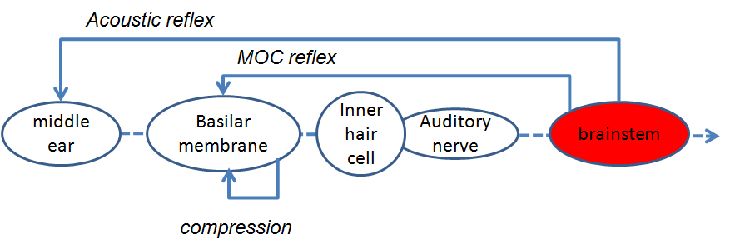

Individual brain cell responses are modelled using MacGregor’s(1987) point neuron model. This model has the advantage of simplicity and rapid execution time while retaining a modicum of flexibility so that different kinds of cells can be represented. The account below covers only sustained chopper responses. An introduction to the general model can be found in Meddis and O’Mard (2006) and Hewitt and Meddis (1994).

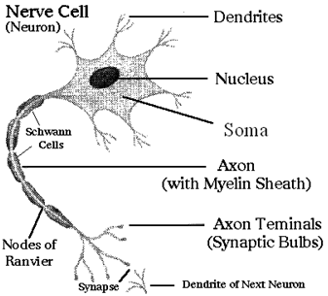
Figure 19: Schematic of a nerve cell.

The input to a model cell consists of streams of action potentials; either from AN spikes or other brainstem units. The output from the cell is a single stream of action potentials. Input and output spikes are modelled as Dirac pulses and represented as a stream of 0s and 1s. These are stored by the software as logical matrices.

A single-cell model consists of two stages:
- Input at the dendrites
- Spike-generation at the soma.

Dendrites
The dendrite input stage converts each input spike(effectively a Dirac pulse) into an alpha function, α(t), to simulate the rise and fall of a post synaptic potential as it would be measured at the soma
α(t)= I_{spike} τ t exp(-t / τ) (0 < t < 5 τ)
where I_{spike} is the current per spike and τ is a time constant representing the spatial and temporal integration of post-synaptic potentials. An AN spike will produce a smaller and slower voltage rise when it is distant from the soma. This can be thought of as a low pass filter with a cutoff frequency, f_{c}
τ = 1 / (2 π f_{c})

This cutoff frequency is lower for synapses on remote dendrites. Synapses close to the soma have shorter, higher alpha functions. Sustained chopper neurons are modelled using synapses remote from the soma and have cutoff frequencies in the region of 50-100 Hz. For computational convenience only, the synapses are assumed to be all equally distant from the soma and to deliver the same amount of current.
MacGregorMultiParams.dendriteLPfreq=50;
MacGregorMultiParams.currentPerSpike=30e-9;

f_{c}= 50  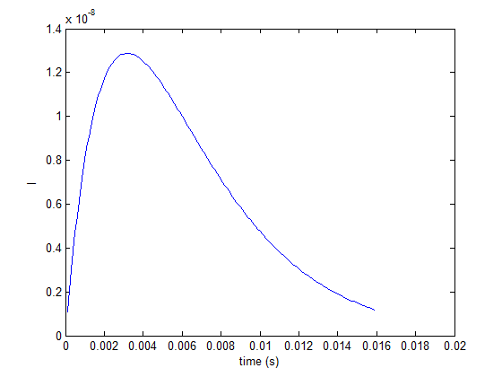 | f_{c}= 200  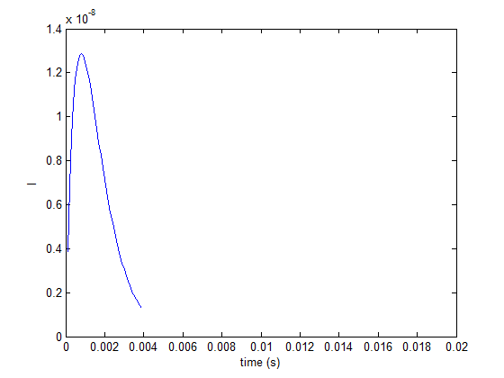
Figure 20: Alpha functions computed using low pass filters of 50 Hz (left) and 200 Hz (right).

The alpha function is convolved individually with every input spike to generate the post-synaptic current, I_{t}.

Soma
The voltage measured at the cell soma, E, is represented as a deviation from resting potential, Er, and tracked using the equation
dE(t) / dt = −E(t) / τ_{m} + I(t) R + Gk(t) [Ek – E(t)]
where τ_{m} is the membrane time constant of the cell, R is the cell membrane resistance, Ek is the potassium reversal potential relative to Er and Gk(t) is the cell potassium conductance relative to its resting value. Note that this equation represents three processes. First, −E(t) / τ_{m} is the decay of the ongoing voltage. Second, I(t) R is the voltage change caused by the input current (from the post-synaptic potentials. Third, Gk(t) [Ek – E(t)] represents a reduction in voltage that occurs after an action potential. This is a short-lasting change because the conductance Gk rapidly falls back to zero. In the absence of any input, E(t) falls to zero which is effectively the resting potentials (see first sentence)

When the membrane potential exceeds a threshold, E(t)>Th0, an action potential is initiated. To signal this, a variable s is set to 1 for a single epoch; otherwise this spiking variable is always 0. When an action potential occurs, Gk is increased by a fixed amount, b, before drifting back to its resting value of zero. When Gk, the potassium conductance, is increased, the voltage is pulled down to levels below resting values. In the absence of any input, the voltage gradually returns to resting as Gk returns to its own resting value.

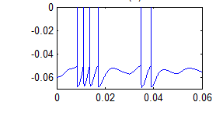
Figure 21: Example of the output from the McGregor model showing action potentials followed by hyperpolarisation. Occasional small humps indicate synaptic currents that were not large enough to initiate an action potential.

Gk is tracked as follows
dGk(t) / dt = − Gk(t) / τ_{Gk} + (b · s)
where τ_{Gk} is the potassium time constant.

Connectivity
The base model uses the following arrangement of connections. A band of AN fibers (all from the same BF converge on a CN chopper cell. The output from a band of (same BF) CN choppers converges on a single level-2 chopper unit. This repeated across all BF channels.
The first layer of cells are, obviously CN units. The second layer of cells are a more abstract entity and can be thought of as IC units or as MSO units. These are beyond the cochlear nucleus. How we view this level 2 cell depends on the task in hand. For the model of efferent activity described below, it is convenient to think of the second layer as the MSO because the activity in these units determines the amount of efferent activity of the medial olivocochlear bundle. Alternatively we could think of it as a set of motor neurons controlling the acoustic reflex. When harnessed to multiThreshold for psychophysical evaluation of the model we might think of it as a unit in the inferior colliculus (IC) responsible for detecting the presence of any sound. Clearly, this model leaves considerable room for refinement but it gets the show on the road. The main thing is to view the level 2 unit flexibly as any higher-order brainstem response. The next software release (not any time soon) will aim for an improved brainstem representation.

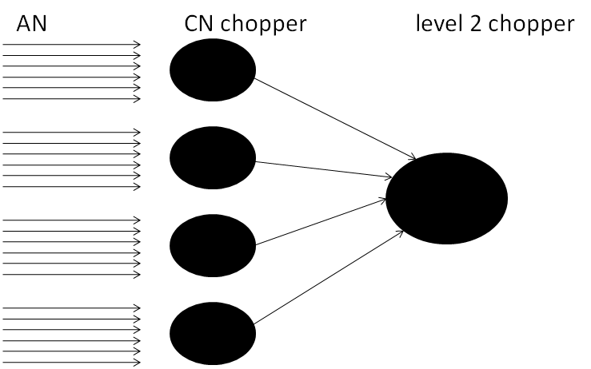
Figure 22: Schematic of neuronal circuitry in the MAP model (see text). The circuit for a single BF is shown. This will be replicated for each channel in the model.

Both CN and level two units use the MacGregor model. However, they are controlled by different sections of code and they have different parameters. They are handled by different code for historical reasons and this may change in future because there is no fundamental difference between them. The parameters governing these stages can be found in the parameter files: MacGregorMulitParams for CN units and MacGregorParams for level-2 units. The terminology is unhelpful and will be changed in the future when there is a major overhaul of code to give greater flexibility to managing brainstem simulations.
If more than one AN fiber type is used (e.g. HSR and LSR), this scheme is replicated independently for each type with no direct communication between the two sets of activity.
When only one fiber type is used, there is only one level-2 neuron per BF. When two fiber types are used, there are two level-2 neurons per BF, etc.. It is necessary to use both HSR and LSR fiber types to simulate efferent effects. All fiber types controls the MOC while only the LSR fiber group controls the AR. This is, of course, a speculative feature of the model but it is convenient that HSR fibers have low thresholds while LSR fibers have high thresholds. This agrees with the physiologically-measured thresholds of the two types of efferent activity.

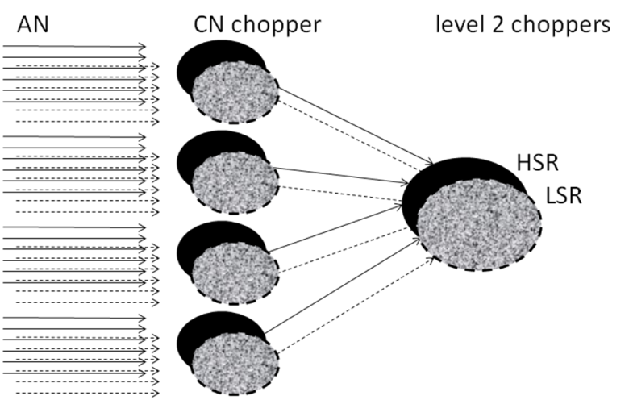
Figure 23: Same as previous figure except that the system is replicated for HSR and LSR fibers. This pattern will be replicated for each BF channel. The standard version of the model uses three fiber types but the number is arbitrary. AN fibers vary considerably in terms of their firing rates and thresholds.

CN chopper cells fire regularly when tested in vitro and the rate of firing depends on the amount of injected current with little sign of saturation. In vivo, however, the rate of firing increases along with the level of the stimulating tone but the effect quickly saturates. This reflects the saturation of the AN input fibers that are carrying the signal. Typically, the chopping rate is constant as levels close to threshold. This gives the impression that the chopper has an ‘intrinsic rate’. This rate can be set using the potassium recovery time constant, τ_{Gk} , but it is also influenced by the current per spike, I_{spike} , and the number of AN fibers supplying input.

Cochlear Nucleus units
Cochlear nucleus (CN) units are the first layer of brainstem cells in the model. A number of sustained units (typically 10) are computed within each BF channel for each stream of AN fiber types.
MacGregorMultiParams.nNeuronsPerBF= 10;

Each unit receives a number of AN fiber inputs.
MacGregorMultiParams.fibersPerNeuron=10;

It may seem confusing to have the same number of input fibers per unit as the number of units; this is not obligatory. However, it has the advantage of keeping the parameters of the level 2 units similar to the CN units because the level-2 units receive input from 10 CN units. There is no special theory behind these parameters, they are largely arbitrary but they work.
The input fibers are chosen at random (with replacement) from all available AN fibers in that channel (and fiber type). Typically, there will be 100 AN fibers available within each fiber type category at each BF.
The first stage of processing is the conversion of the input spikes to a dendritic current as explained above
MacGregorMultiParams.dendriteLPfreq=50;
MacGregorMultiParams.currentPerSpike=30e-9;

The parameters of the CN units are typically adjusted to have a low spontaneous rate (close to 10 spikes/s) and a sustained rate of over 200 spikes/s at high signal levels. Sustained chopper units should show steady, equally spaced spiking activity when adequately stimulated by a pure tone
MacGregorMultiParams.Cap= 1.67e-8;
MacGregorMultiParams.tauM= 0.002;
MacGregorMultiParams.Ek= -0.01;
MacGregorMultiParams.dGkSpike= 1.33e-4;
MacGregorMultiParams.tauGk= 0.0005;
MacGregorMultiParams.Th0= 0.01;

If independent sets of AN fibers have been modelled (e.g. HSR and LSR), independent streams of CN units will also be computed.

Level 2 units
The operation of these units is essentially the same as those for the CN units although they have different (if similar) parameters. They take their input from the CN units and maintain the parallel architecture so that there is no cross-talk between BFs or betweeen streams originating from different AN fiber types.. The software assumes that there are an equal number of CN units in each Bf channel and an equal number of CN units in each fiber type. it is, therefore, important that the fibersPerNeuron parameter is equal to the number of CN units available (in this case 10) in each BF/ fiber combination. The parameters of the level 2 units are adjusted against the following criteria
- A zero spontaneous rate. This is essential when evaluating the model using psychophysical techniques because any spike at this level can be taken to indicate the detection of an acoustic signal. Few units in the brainstem have zero spontaneous rate. However, for many reasons it is convenient to do so in the model. These units act as detectors identifying when the signal has exceeded some threshold. This is particularly useful when modelling psychophysical phenomena and the model is asked to make a yes/no decision. Any spiking activity is treated as a ‘yes’.
- The rate threshold (in dB SPL) must be as low as possible while maintaining a zero spontaneous rate. This guarantees that the model is operating as efficiently as possible

MacGregorParams.fibersPerNeuron=10;
MacGregorParams.dendriteLPfreq=100;
MacGregorParams.currentPerSpike=120e-9;
MacGregorParams.currentPerSpike=40e-9;
MacGregorParams.Cap=16.7e-9;
MacGregorParams.tauM=0.002;
MacGregorParams.Ek=-0.01;
MacGregorParams.dGkSpike=1.33e-4;
MacGregorParams.tauGk= 0.0012;
MacGregorParams.Th0= 0.01;

Cochlear Nucleus: Evaluation
The responses of the CN and level 2 units can be visualized using the testAN function in the testPrograms folder. This shows the rate/level function for both CN and level 2 neurons for HSR and LSR fiber type streams.
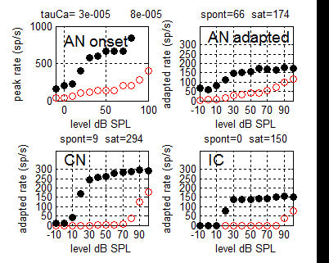
Figure 24: Rate/ level functions for auditory nerve fibers, first- and second-level brainstem units. Two streams are represented, HSR (black, filled) and LSR (red). The tests are based on 200-ms tones at BF (=1 kHz). AN onset rate is based on spikes in the 1-ms bin with the most spikes. Other panels are adapted rates based on the final 100 ms.
The following example confirms that level-2 units have a zero spontaneous rate while the CN units have low spontaneous rate. The firing of chopper units is more regular than that of AN units. This is measured by the coefficient of variation. The figure shows that this statistic is much greater for the AN than for the CN choppers at all levels tested

-10 dB SPL  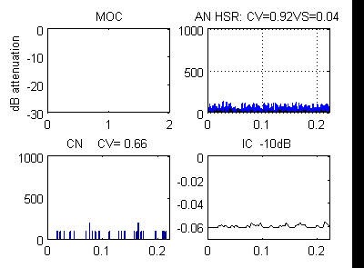 | 10 dB SPL  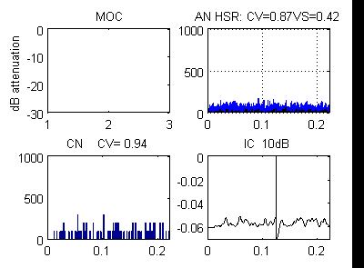
40 dB SPL  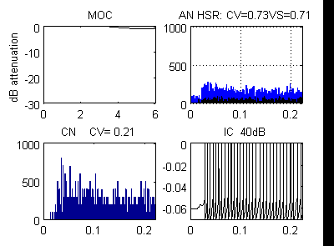 | 60 dB SPL  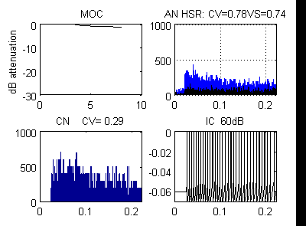
Figure 25: AN, CN chopper and level-2 chopper responses to 200-ms, 1000-Hz pure tones at 4 levels (-10, 10, 40 and 60 dB SPL). Each panel consists of four sub-panels; top left: response of the MOC and AN efferent systems (see section ? below), top right: AN PSTH, bottom left: CN units PSTH; bottom right: spiking pattern of a single level-2 cell (indicated as IC). The coefficient of variation (CV) is shown for the AN and CN spike trains. The vector strength (VS) otherwise known as the synchronisation index (see AN section above) is also shown.

Efferent activity (AR and MOC)

The peripheral efferent system is modelled as two separate functions; the acoustic reflex (AR) and the medial olivo cochlear (MOC) efferents. Both are driven by neuronal activity in the auditory brainstem and suppress the response of the periphery to sound. In the model, the controlling neurons are level-2 units. The AR is controlled by level-2 units in the LSR stream while the MOC is controlled by level-2 units in all streams.

Acoustic Reflex
This topic is under active development and the author should be consulted for the latest picture.
The acoustic reflex (AR) is an attenuation applied to the stapes displacement. The amount of attenuation is based on the single brainstem level-2 activity in the LSR stream. This is intended to represent MSO units that receive inputs from CN (chopper) units in the LSR stream. The acoustic reflex has a high threshold and the choice of LSR AN fibers as the controlling source is simply to guarantee high thresholds. The response is strongest for wideband signals. For this reason the model AR is driven by the mean rate of firing across all channels combined. Animal measurements (Hung and Dallos, 1972) show that the rate of rise of the AR effect is level dependent and its threshold is high (around 70 dB SPL).

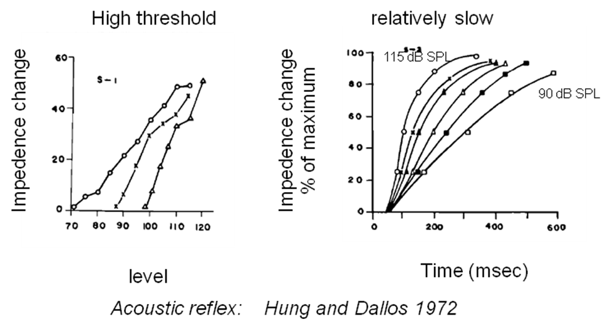
Figure 26: Hung and Dallos (1972). Left panel: input/output functions at the acoustic reflex. Open circles are wideband noise; crosses are 1 kHz and triangles are 600 Hz. Right panel: build up to maximum strength at a range of signal levels at 1 kHz.
The degree of attenuation is computed as the mean (across all BFs) of the activity in all level 2 units in the LSR stream. This sum is smoothed using a 1st order low pass filter with a time constant of 250 ms to create a firing rate r(LSR)_{t}, and then adjusted using a scalar to generate a gain factor, AR_{t}
AR_{t} = 1 - rateToAttenuationFactor . r(LSR)_{t}
which is applied to the stapes displacement (see outer-middle ear section above).
OMEParams.rateToAttenuationFactor=0.03;
OMEParams.ARtau=.250;
Because r(LSR)_{t} is intended to be an across-frequency measure of AN activity, it should be clear that this estimate is more accurate when a large number of BF channels covering a wide range of frequencies is used. If only one channel is used, MAP1_14 automatically disables the acoustic reflex.

MOC Reflex
The MOC reflex is an attenuation applied to the BM displacement. A within-channel attenuation is computed in each BF channel and applied to the same channel.
The MOC reflex has a low threshold and for this reason the attenuation is computed on the basis of brainstem level-2 neurons in the HSR stream. This guarantees relatively thresholds of activation.

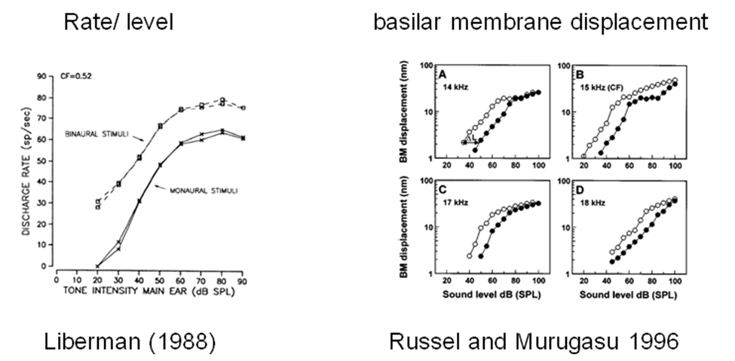
Figure 27: Examples of measurements showing the effect of MOC suppression. Left: Spike rate of MOC efferent fibers as a function of pure tone intensity (Liberman, 1988). Right: Depression of BM response following electrical stimulation of the MOC bundle.
The MOC response is based on the sum total of all firing of the second-level neurons in a particular BF channel. There is only one level-2 unit in each channel for each AN fiber-type stream. If there are 3 fiber types, the MOC response is based on the firing rate of all three level-2 units. The spiking sum, r_{t}, is smoothed using a lowpass filter with a time constant of 25 ms (cutoff 6 Hz) and then adjusted using a scalar (currently 0.0063) to generate a gain factor, MOC_{t}
MOC_{t} = 1 – rateToAttenuationFactor . r_{t}
DRNLParams.MOCtau1= .068; % smoothing for MOC1
DRNLParams.rateToAttenuationFactor1= 0.0351; % strength of MOC1

In fact, the smoothing process uses two lowpass filters to conform with the suggestion by Guinan et al that the decay of the MOC effect following stimulation follow a double exponential time curse.

DRNLParams.MOCtau2=0.3; % smoothing for MOC2
DRNLParams.rateToAttenuationFactor2= 0.045; % strength of MOC 2

Once the MOC efferent strength has been computed, it is applied to the BM displacement for the corresponding BF channel in the nonlinear path only. Displacements in the linear path are not affected. Note that the MOC attenuation can become irrelevant when the output from the linear path is dominant. However, at high levels the AR will also be active and this will affect the output irrespective of the DRNL pathway dominance. Yes, these feedback loops operating in a nonlinear world and the complexities can be very trying.
The strength of the MOC is subject to a maximum value (in dB).
DRNLParams.minMOCattenuationdB=-35;

AR and MOC: Evaluation

Attenuation of BM response
The response of the MOC can be visualized using test_MAP1_14 when it is set up to respond to a pure tone stimulus.
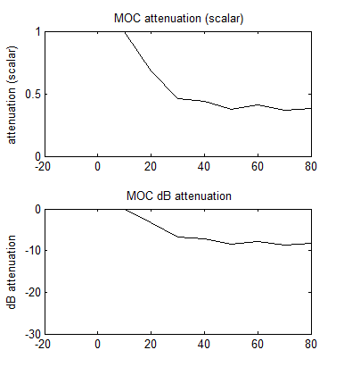
Figure 28: The BM attenuation/ level function. Top panel: attenuation as a scalar. Bottom panel: attenuation in dB.
Note that the MOC builds up over time. The amount of attenuation will depend on the length of the test tone.

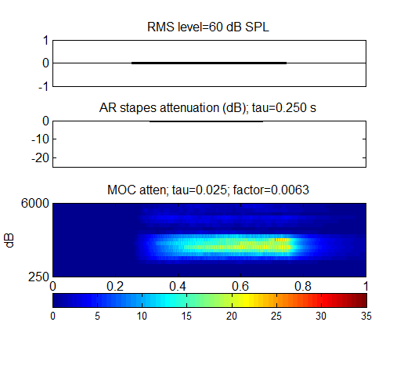 | 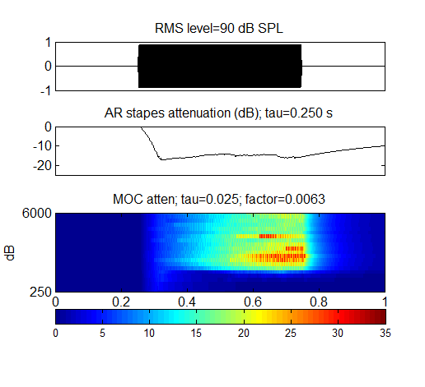
Figure 29: AR and MOC attenuation for a multi-channel model. Left panel:60-dB SPL, 1-kHz pure tone. Right panel: 90-dB SPL 1-kHz pure tone.
A check on the appropriateness of the MOC time constant can be made using the program testBackus2006 in the testPrograms folder. This measures the time course of the growth of the MOC efferent activity in response to a 60 dB SPL 2-ms, 1-kHz tone. The model uses two time constants derived directly from Backus and Guinan’s table II; fast, medium = 68ms, d 300 ms respectively and relative strength in the ratio 1.5:1.

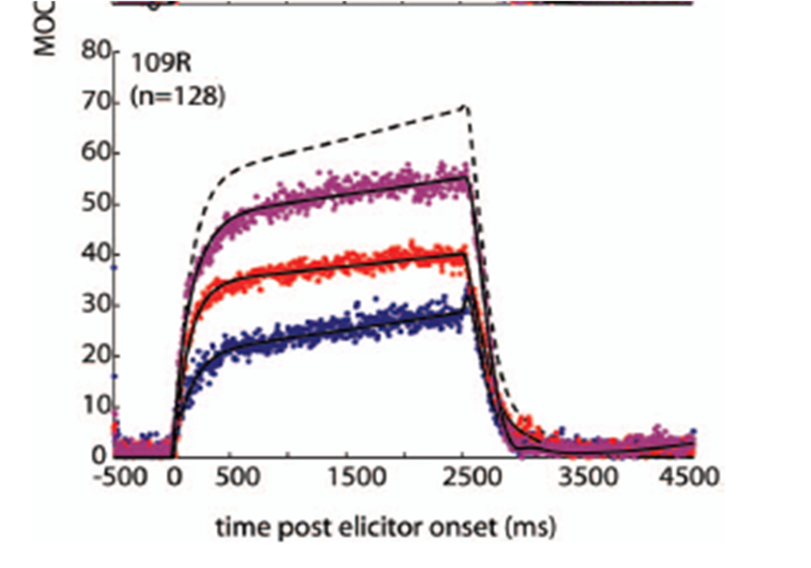 | 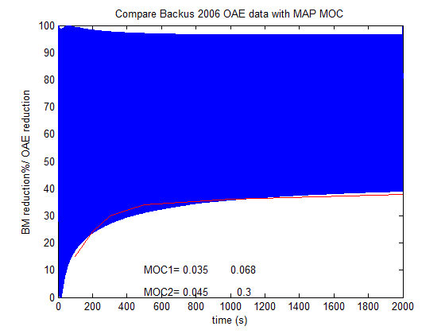
Figure 30: Left: Backus and Guinan (2006) measurements of MOC strength to a 60 dB SPL white noise presented contralaterally (middle of the three curves). They measured MOC activity in terms of OAE reduction in the ipsilateral ear. Right: MAP response to an ipsilateral 1-kHz pure tone shown as % reduction in BM reduction is shown as the white area under the blue shading.

AR and MOC using the probability model
The probability model is a fast method for evaluating MAP but it lacks a representation of the brainstem activity necessary to control the efferent pathways. As a work-around we can use the AN firing rates for HSR and LSR fibers to act as a proxy. From many points of view, the approximation works well and is certainly good enough for the purposes of exploratory studies.
The implementation works by analogy, substituting the mean firing rate across all LSR fibers in ALL channels as the control signal for the acoustic reflex. A different gain value is required
OMEParams.rateToAttenuationFactorProb=0.02;

The same applies to the MOC. However, a new parameter is required to discount the high spontaneous rate of the HSR AN fibers. An estimate of the spontaneous rate of firing of HSR AN fibers can be found by running testANprob in the testPrograms folder.
DRNLParams.MOCtauProb1 =.050; % smoothing for MOC
DRNLParams.rateToAttenuationFactorProb1 = .3; % strength of MOC
DRNLParams.MOCtauProb2 =.25; % smoothing for MOC
DRNLParams.rateToAttenuationFactorProb2 = 1; % strength of MOC
DRNLParams.MOCrateThresholdProb =80; % spikes/s probability only

The MOCrateThresholdProb parameter is subtracted from the HSR within-channel rate before the attenuation factor is applied. This process guarantees that the MOC will not be triggered below absolute threshold. A similar process might be applied to the AR computations but, normally, this will have little effect because the LSR spontaneous rate of firing is typically close to zero.

Bibliography
Dallos, P. (1986). “Neurobiology of cochlear inner and outer hair cells: intra cellular recordings”, Hearing Research, 22, 185-198.
Hewitt, M.J. and Meddis, R., (1994). A Computer Model of Amplitude-Modulation Sensitivity of Single Units in the Inferior Colliculus. J.Acoust. Soc. Am.95 (4), April 1994, 2145-2159.
Huber, A., Linder, T., Ferrazzini, M., Schmid, S., Dillier, N., Stoeckli, S., and Fisch, U. (2001). "Intraoperative assessment of stapes movement," Ann Otol Rhinol Laryngol 110, 31-35.
Hung, I.J. and Dallos, P. (1972). “Study of the Acoustic Reflex in Human Beings. I. DynamicCharacteristics”, J.Acoust. Soc. Am., 52, 1168-1180.
Johnson, D.H. (1980). “The relationship between spike rate and synchrony in responses of auditory nerve fibers to single tones“, J. Acoust. Soc. Am., 68, 1115- 1112.
Liberman, M.C. (1988) "Physiology of cochlear efferent and afferent neurons: Direct comparisons in the same animal", Hearing Research, 34, 179-192.
Lopez-Poveda, E. A. and Meddis, R. (2001). A human nonlinear cochlear filterbank. Journal of the Acoustical Society of America 110 (6): 3107-3118.
MacGregor, R. J. (1987). Neural and Brain Modeling, Academic, San Diego
Meddis, R. (1986). Simulation of Mechanical to Neural Transduction in the Auditory Receptor. Journal of the Acoustical Society of America 79, 702-711.
Meddis, R. (1988). Simulation of Mechanical to Neural Transduction: Further Studies. Journal of the Acoustical Society of America 83, 1056-1063.
Meddis, R. (2006). Auditory-nerve first-spike latency and auditory absolute threshold: a computer model. Journal of the Acoustical Society of America 119, 406-417.
Meddis, R., Hewitt, M. J. and Shackleton, T. (1990). Implementation details of a computational model of the inner hair-cell/auditory-nerve synapse. Journal of the Acoustical Society of America 87, 1813-1818. (download pdf)
Meddis, R., O'Mard, L.P. and Lopez-Poveda, E.A. (2001) A computational algorithm for computing nonlinear auditory frequency selectivity. Journal of the Acoustical Society of America, 109, 2852-2861.
Patuzzi, R., and Sellick, P.M. (1983) "A comparison between basilar membrane and inner hair cell receptor potential input-output functions in the guinea pig cochlea", J. Acoust. Soc. Am., 74, 6, 1734-1741.
Ruggero and Temchin (2002), ‘The roles of the external, middle, and inner ears in determining the bandwidth of hearing’, PNAS, 99, 13206–13210.
Ruggero, M.A., Rich, N.C., Recio, A., Narayan, S.S., and Robles, L. (1997) " Basilar-membrane responses to tones at the base of the chinchilla cochlea", J. Acoust. Soc. Am., 101, 4, 2151-2163.
Ruggero, M.A., Robles, R.L. and Rich, N.C. (1986). Basilar membrane mechanics at the base of the chinchilla cochlea. J. Acoust. Soc. Am., 80, 1375-1385.
Russell, I. J., and Murugasu, E. (1997). “Medial efferent inhibition suppresses basilar membrane responses to near characteristic frequency tones of moderate to high intensities,” J. Acoust. Soc. Am. 102, 1734–1738.
Shamma, S.A., Chadwick, R.C., Wibur, W.J., Morrish, K.A., and Rinzel, J. (1986) "A biophysical model of cochlear processing: Intensity dependence of pure tone responses", J. Acoust. Soc. Am., 80, 1, 133-145.
Sumner, C., Lopez-Poveda, E.A., O'Mard, L.P. and Meddis, R. (2003). Adaptation in a revised inner-hair cell model. Journal of Acoustical Society of America, 113, 893-901.
Sumner, C., O'Mard, L.P., Lopez-Poveda, E.A., and Meddis, R. (2003). A non-linear filter-bank model of the guinea-pig cochlea. Journal of Acoustical Society of America 113, 3264-3274.
Sumner, C.J., O'Mard, L.P., Lopez-Poveda, E.A., and Meddis, R. (2002). A revised model of the inner-hair cell and auditory nerve complex. Journal of the Acoustical Society of America, 111, 2178-2189.
Cho, Y., Seo, I. Woo, H., Kang, M., Chung, W., and Hong, S. (2001). “Changes in External Ear Resonance after 3 Types of Surgery in the Patients with Chronic Otitis Media”, Otolaryngology - - Head and Neck Surgery, 2001 125: 364-369.
Kiang, N.Y.S. and Moxon, E.C. (1972). Ann. Otol. Rhin. Laryng., 81, 714-730.

